Oberon Ilano

CS 447

Lab 10

Assuming hd is measured in Megabytes (1 GB = 1000 MB)

mysql> CREATE VIEW entryLevel AS SELECT model, speed, PC.ram, PC.hd, price FROM PC WHERE ram <= 1000 AND hd < 200;

Query OK, 0 rows affected (0.01 sec)

mysql> select * from entryLevel;

+-------+-------+-----+----+-------+

| model | speed | ram | hd | price |

+-------+-------+-----+----+-------+

| 1003 | 1.42 | 512 | 80 | 478 |

| 1013 | 3.06 | 512 | 80 | 529 |

+-------+-------+-----+----+-------+

2 rows in set (0.00 sec)

**2.**

mysql> CREATE VIEW colorPrinters AS SELECT Product.manufacturer, Product.model, Product.type FROM Product, Printer WHERE color = 1 AND Product.model = Printer.model;

Query OK, 0 rows affected (0.01 sec)

mysql> select * from colorPrinters;

+--------------+-------+---------+

| manufacturer | model | type |

+--------------+-------+---------+

| d | 3004 | printer |

| E | 3001 | printer |

| E | 3003 | printer |

| G | 3006 | printer |

| H | 3007 | printer |

+--------------+-------+---------+

5 rows in set (0.00 sec)

**3.**

mysql> CREATE VIEW PCLaptop AS SELECT model, speed, ram, hd, price FROM PC UNION ALL SELECT model, speed, ram, hd, price FROM Laptop;

Query OK, 0 rows affected (0.01 sec)

mysql> select * from PCLaptop;

+-------+-------+------+-----+-------+

| model | speed | ram | hd | price |

+-------+-------+------+-----+-------+

| 1001 | 2.66 | 1024 | 250 | 2114 |

| 1002 | 2.1 | 512 | 250 | 995 |

| 1003 | 1.42 | 512 | 80 | 478 |

| 1004 | 2.8 | 1024 | 250 | 649 |

| 1005 | 3.2 | 512 | 250 | 630 |

| 1006 | 3.2 | 1024 | 320 | 1049 |

| 1007 | 2.2 | 1024 | 200 | 510 |

| 1008 | 2.2 | 2048 | 250 | 770 |

| 1009 | 2 | 1024 | 250 | 650 |

| 1010 | 2.8 | 2048 | 300 | 770 |

| 1011 | 1.86 | 2048 | 160 | 959 |

| 1012 | 2.8 | 1024 | 160 | 649 |

| 1013 | 3.06 | 512 | 80 | 529 |

| 2001 | 2 | 2048 | 240 | 3673 |

| 2002 | 1.73 | 1024 | 80 | 949 |

| 2003 | 1.8 | 512 | 60 | 549 |

| 2004 | 2 | 512 | 60 | 1150 |

| 2005 | 2.16 | 1024 | 120 | 2500 |

| 2006 | 2 | 2048 | 80 | 1700 |

| 2007 | 1.83 | 1024 | 120 | 1429 |

| 2008 | 1.6 | 1024 | 100 | 900 |

| 2009 | 1.6 | 512 | 80 | 680 |

| 2010 | 2 | 2048 | 160 | 2300 |

+-------+-------+------+-----+-------+

23 rows in set (0.00 sec)

Assuming hd is measured in Megabytes (1 GB = 1000 MB)

mysql> CREATE VIEW performanceModels AS SELECT DISTINCT manufacturer, PCLaptop.model, PCLaptop.speed, PCLaptop.ram, PCLaptop.hd, PCLaptop.price, Product.type FROM Product NATURAL JOIN PCLaptop WHERE PCLaptop.speed >= 2 AND PCLaptop.ram > 1000 ORDER BY (price);

Query OK, 0 rows affected (0.01 sec)

mysql> select * from performanceModels;

+--------------+-------+-------+------+-----+-------+--------+

| manufacturer | model | speed | ram | hd | price | type |

+--------------+-------+-------+------+-----+-------+--------+

| C | 1007 | 2.2 | 1024 | 200 | 510 | pc |

| B | 1004 | 2.8 | 1024 | 250 | 649 | pc |

| E | 1012 | 2.8 | 1024 | 160 | 649 | pc |

| d | 1009 | 2 | 1024 | 250 | 650 | pc |

| d | 1008 | 2.2 | 2048 | 250 | 770 | pc |

| d | 1010 | 2.8 | 2048 | 300 | 770 | pc |

| B | 1006 | 3.2 | 1024 | 320 | 1049 | pc |

| A | 2006 | 2 | 2048 | 80 | 1700 | laptop |

| A | 1001 | 2.66 | 1024 | 250 | 2114 | pc |

| G | 2010 | 2 | 2048 | 160 | 2300 | laptop |

| A | 2005 | 2.16 | 1024 | 120 | 2500 | laptop |

| E | 2001 | 2 | 2048 | 240 | 3673 | laptop |

+--------------+-------+-------+------+-----+-------+--------+

12 rows in set (0.00 sec)

**4.**

mysql> show INDEXES FROM Product;

Empty set (0.00 sec)

mysql> CREATE INDEX iProductModel ON Product(model);

Query OK, 0 rows affected (0.17 sec)

Records: 0 Duplicates: 0 Warnings: 0

mysql> show INDEXES FROM Product;

+---------+------------+---------------+--------------+-------------+-----------+-------------+----------+--------+------+------------+---------+---------------+

| Table | Non_unique | Key_name | Seq_in_index | Column_name | Collation | Cardinality | Sub_part | Packed | Null | Index_type | Comment | Index_comment |

+---------+------------+---------------+--------------+-------------+-----------+-------------+----------+--------+------+------------+---------+---------------+

| Product | 1 | iProductModel | 1 | model | A | 30 | NULL | NULL | | BTREE | | |

+---------+------------+---------------+--------------+-------------+-----------+-------------+----------+--------+------+------------+---------+---------------+

1 row in set (0.00 sec)

**5.**

mysql> show INDEXES FROM PC;

Empty set (0.00 sec)

mysql> CREATE INDEX iPCmodel ON PC(model);

Query OK, 0 rows affected (0.14 sec)

Records: 0 Duplicates: 0 Warnings: 0

mysql> CREATE INDEX iPCprice ON PC(price);

Query OK, 0 rows affected (0.08 sec)

Records: 0 Duplicates: 0 Warnings: 0

mysql> show INDEXES FROM PC;

+-------+------------+----------+--------------+-------------+-----------+-------------+----------+--------+------+------------+---------+---------------+

| Table | Non_unique | Key_name | Seq_in_index | Column_name | Collation | Cardinality | Sub_part | Packed | Null | Index_type | Comment | Index_comment |

+-------+------------+----------+--------------+-------------+-----------+-------------+----------+--------+------+------------+---------+---------------+

| PC | 1 | iPCmodel | 1 | model | A | 13 | NULL | NULL | | BTREE | | |

| PC | 1 | iPCprice | 1 | price | A | 13 | NULL | NULL | | BTREE | | |

+-------+------------+----------+--------------+-------------+-----------+-------------+----------+--------+------+------------+---------+---------------+

2 rows in set (0.00 sec)

**6.**

mysql> DROP INDEX iPCprice ON PC;

Query OK, 0 rows affected (0.05 sec)

Records: 0 Duplicates: 0 Warnings: 0

mysql> show INDEXES FROM PC;

+-------+------------+----------+--------------+-------------+-----------+-------------+----------+--------+------+------------+---------+---------------+

| Table | Non_unique | Key_name | Seq_in_index | Column_name | Collation | Cardinality | Sub_part | Packed | Null | Index_type | Comment | Index_comment |

+-------+------------+----------+--------------+-------------+-----------+-------------+----------+--------+------+------------+---------+---------------+

| PC | 1 | iPCmodel | 1 | model | A | 13 | NULL | NULL | | BTREE | | |

+-------+------------+----------+--------------+-------------+-----------+-------------+----------+--------+------+------------+---------+---------------+

1 row in set (0.00 sec)

mysql> show INDEXES FROM PC;

+-------+------------+----------+--------------+-------------+-----------+-------------+----------+--------+------+------------+---------+---------------+

| Table | Non_unique | Key_name | Seq_in_index | Column_name | Collation | Cardinality | Sub_part | Packed | Null | Index_type | Comment | Index_comment |

+-------+------------+----------+--------------+-------------+-----------+-------------+----------+--------+------+------------+---------+---------------+

| PC | 1 | iPCmodel | 1 | model | A | 13 | NULL | NULL | | BTREE | | |

+-------+------------+----------+--------------+-------------+-----------+-------------+----------+--------+------+------------+---------+---------------+

1 row in set (0.00 sec)

**7.**

mysql> ALTER TABLE Laptop ADD CONSTRAINT LKey PRIMARY KEY(model);

Query OK, 0 rows affected (0.21 sec)

Records: 0 Duplicates: 0 Warnings: 0

mysql> show INDEXES FROM Laptop;

+--------+------------+----------+--------------+-------------+-----------+-------------+----------+--------+------+------------+---------+---------------+

| Table | Non_unique | Key_name | Seq_in_index | Column_name | Collation | Cardinality | Sub_part | Packed | Null | Index_type | Comment | Index_comment |

+--------+------------+----------+--------------+-------------+-----------+-------------+----------+--------+------+------------+---------+---------------+

| Laptop | 0 | PRIMARY | 1 | model | A | 10 | NULL | NULL | | BTREE | | |

+--------+------------+----------+--------------+-------------+-----------+-------------+----------+--------+------+------------+---------+---------------+

1 row in set (0.00 sec)

**8.**

DELIMETER |

CREATE TRIGGER myTrigINS

AFTER INSERT ON Laptop

FOR EACH ROW

BEGIN

IF NEW.screen >= 17 THEN

INSERT INTO mvBigScreenLaptops(model, speed, ram, hd, screen, price)

VALUES (New.model, New.speed, New.ram, New.hd, New.screen, New.price);

END IF;

END; |

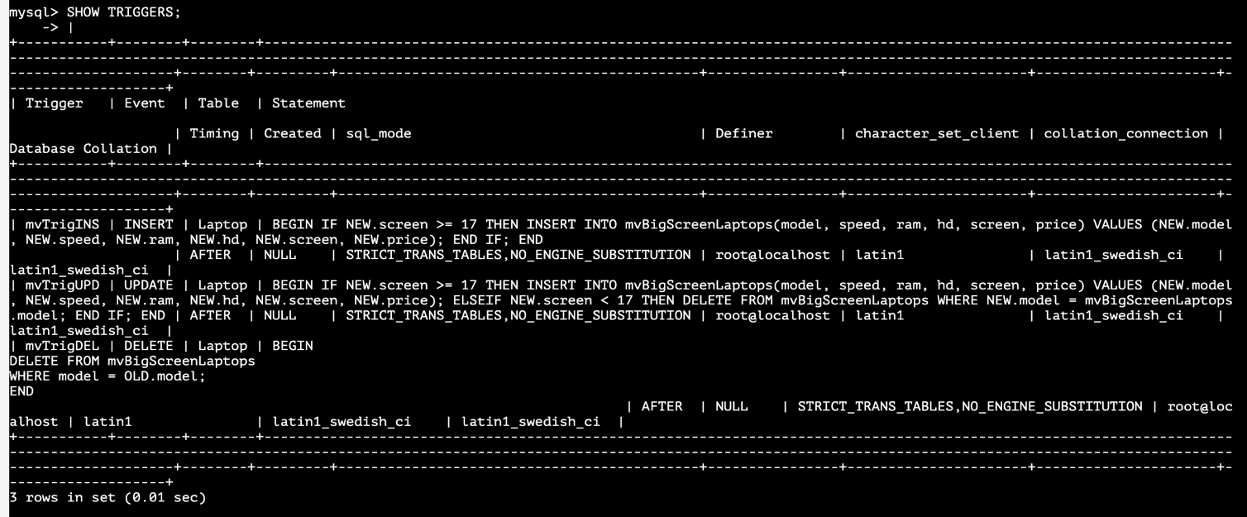

Adding the model 3000 with screen size of 25

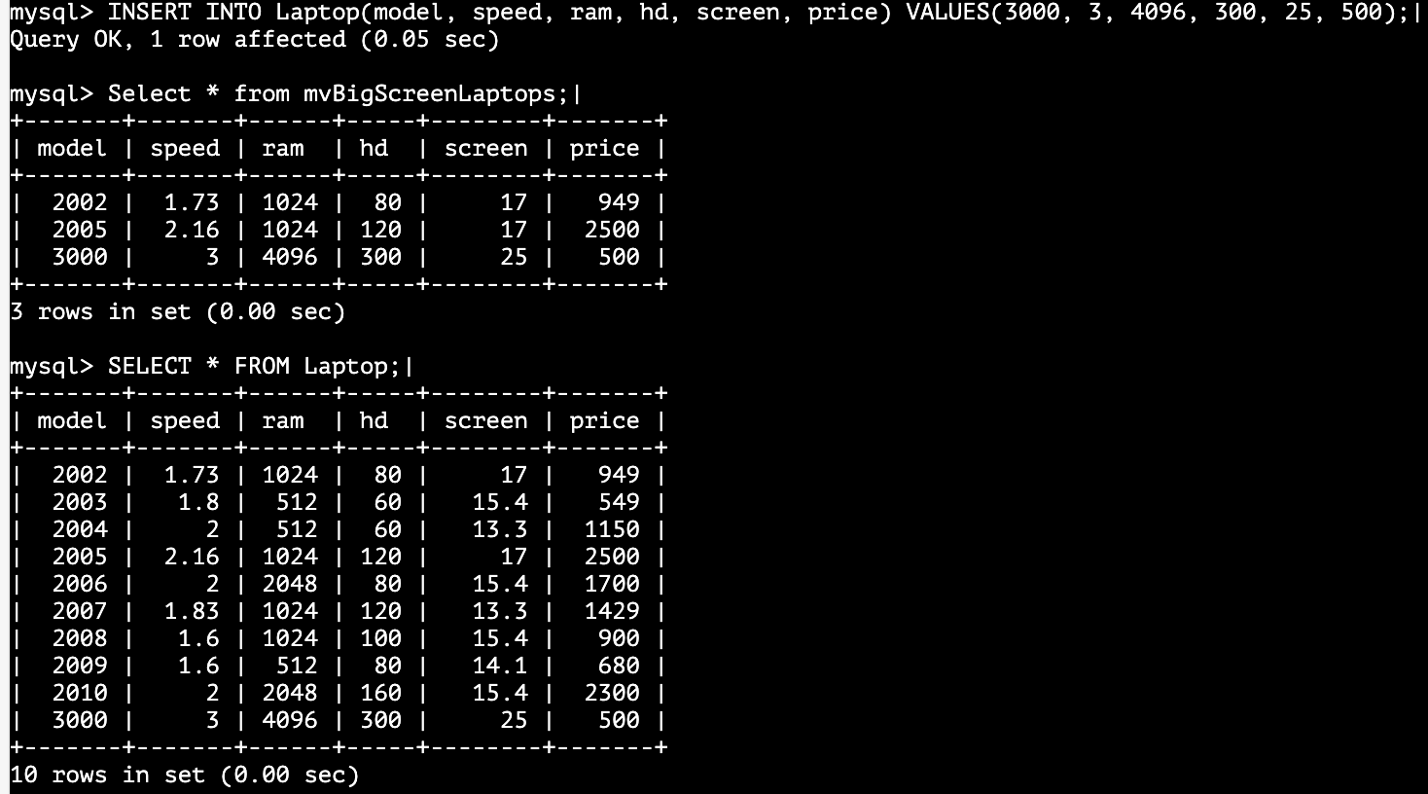

Adding the model 3001 with screen size of 11

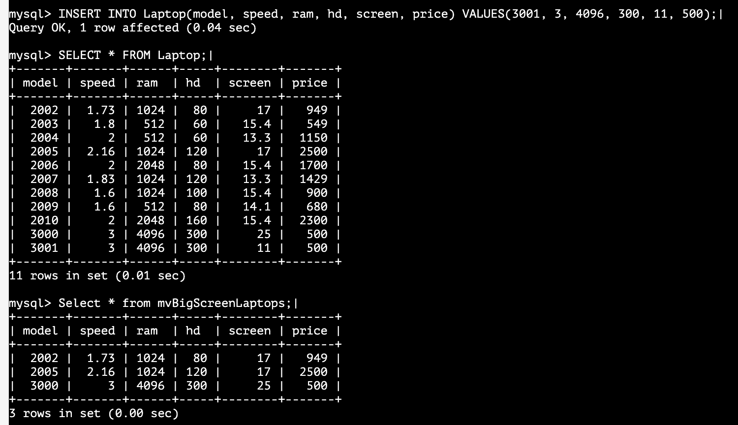

DELIMTER |

CREATE TRIGGER mvTrigDEL

AFTER DELETE ON Laptop

FOR EACH ROW

BEGIN

DELETE FROM mvBigScreenLaptops

WHERE model = OLD.model;

END; |

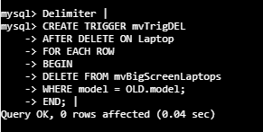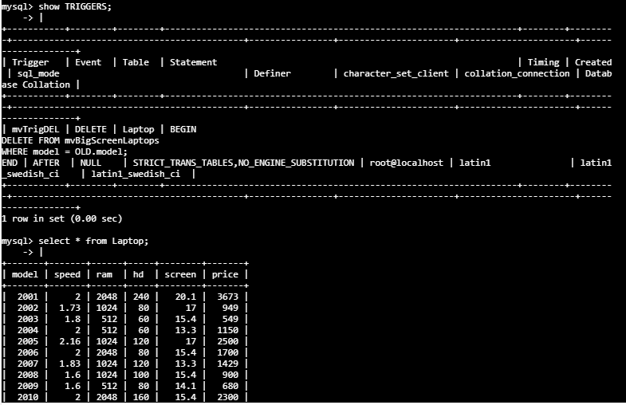

Deleting model 2001

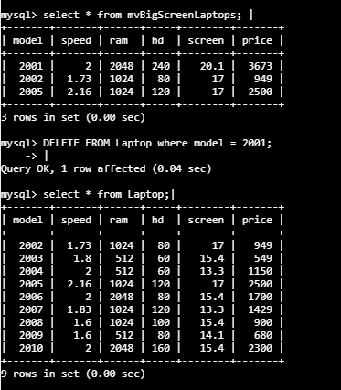

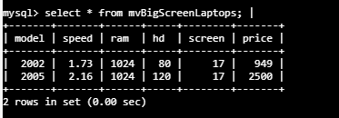

DELIMETER |

CREATE TRIGGER mvTrigUPD

AFTER UPDATE ON Laptop

FOR EACH ROW BEGIN

IF NEW.screen >= 17 THEN

INSERT INTO mvBigScreenLaptops(model, speed, ram,hd, screen, price)

VALUES (NEW.model, NEW.speed, NEW.ram, NEW.hd, NEW.screen, NEW.price);

ELSEIF NEW.screen < 17 THEN

DELETE FROM mvBigScreenLaptops

WHERE NEW.model = mvBigScreenLaptops.model;

END IF;

END; |



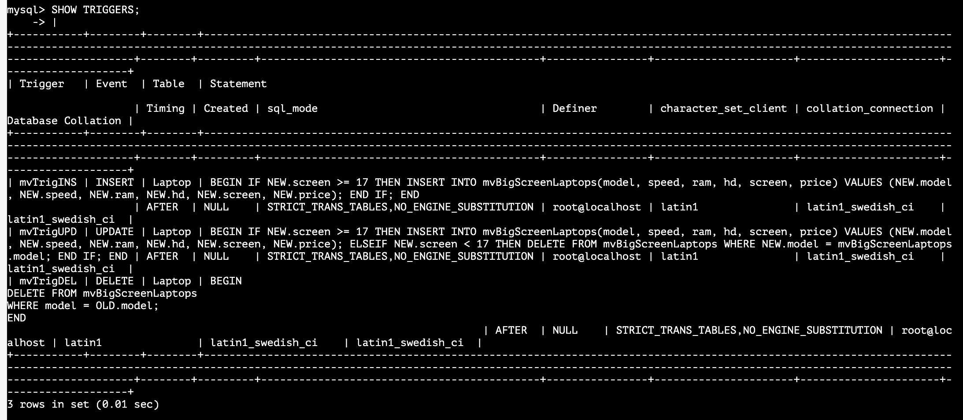

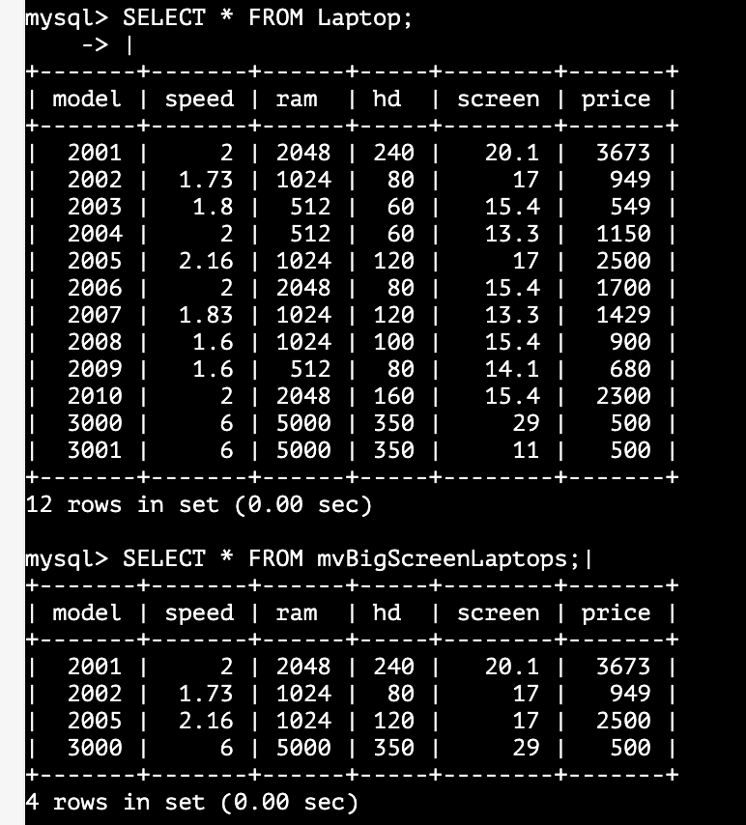

UPDATE MODEL 2003 screen from 17 to 29

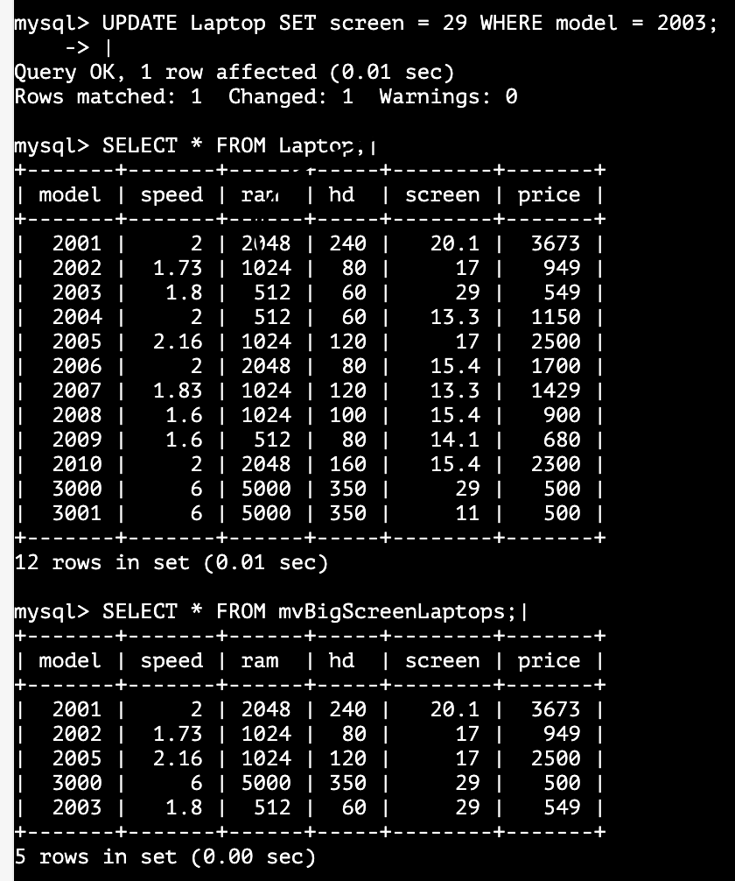

UPDATE model 3000 screen from 29 to 9



UPDATE model 2002 to model 4000 with new data

